Unit 2 Exploring English测试卷
第Ⅰ卷
第一部分：英语知识运用（共两节； 满分45分）
第一节：单项填空（共15小题；每小题1分，满分15分）
1. Besides the influence from their parents’______ is also affected by their peers.
A. behavior B. impression C. error D. performance
2. As Confucius put it, we should ______ on ourselves three times each day.
A. rely B. reflect C. turn D. comment
3. Every one of us is a(n) ______ being in this world, not to be replaced by any other person.
A. particular B. specific C. unique D. especial
4. People who are not vaccinated are more ______ to be infected by COVID-19.
A. possible B. probable C. frightened D. likely
5. ______ his summer holiday experience, he said that he had a lot to share with his classmates.
A. Wondering at B. Speaking of C. Winding up D. Dealing with
6. The situation will not improve unless the common people are more ______ of the pollution problem.
A. negative B. creative C. aware D. confident
7. The pictures on the wall ______ us of the happy junior school days.
A. remind B. memorize C. organize D. explore
8. Please ______ me when you get on the train so that I can meet you at the station.
A. apply B. figure C. recognize D. contact
9. To develop advanced technology, we must first develop ______ in the young people.
A. resource B. opportunity C. facility D. creativity
10. We can find a book in the library either by its ______ or by its author.
A. title B. cover C. context D. section
11. He takes an interest in sports, basketball in ______.
A. particularly B. particular C. addition D. fact
12. If you are ______, it is very likely that an ocean voyage is not suitable for you.
A. carsick B. airsick C. seasick D. homesick
13. In our daily life, we often use a group of capital letters to refer to an organization. For example, we use ______ to stand for the Industrial and Commercial Bank of China.
A. ICBC B. PICC C. PRC D. UNESCO
14. The Beidou system, like GPS, is widely used to ______ vehicles on the road.
A. drive B. name C. position D. schedule
15. Because a(n) ______ goes underground, it is a more effective means of transport for passengers.
A. highway B. subway C. motorway D. airway
第二节：完形填空（共20小题；每小题1.5分，满分30分）
阅读下面短文，从16-35各题所给的四个选项（A、B、C和D）中，选出可以填入空白处的最佳选项并在答题卡上将其涂黑。
Washoe is a young chimpanzee (黑猩猩). She is no __16__ chimpanzee, though. Scientists are doing a research __17__ her. They want to see how civilized(驯化) she can __18__. Already she does many things a human being can do.
For example, she has been learning how to exchange __19__ with people. The scientists are teaching her __20__ language. When she wants to be picked __21__, Washoe points up with one finger. She rubs her teeth with her finger __22__ she wants to brush her teeth. This is done after every meal.
Washoe has also been __23__ to think out and find answers to problems. Once she was put in a __24__ with food hanging from the ceiling. It was too high to __25__. After she considered the __26__, she got a tall box to stand __27__. The food was still too high to be reached. Washoe found a __28__ pole. Then she climbed onto the __29__, grasped the pole, and __30__ down the food with the pole.
Washoe __31__ like a human, too. The scientists keep her in a fully furnished(家具齐全的) house. After a hard __32__ in the laboratory, she goes home. __33__ she plays with her toys. She __34__ enjoys watching television before going to bed.
Scientists hope to __35__ more about people by studying our closest relative(亲属)--chimpanzee.
16.A. foolish B. ordinary C. special D. simple
17.A. for B. by C. to D. on
18.A. experience B. change C. develop D. become
19.A. actions B. views C. messages D. feelings
20.A. sign B. human C. spoken D. foreign
21.A. out B. at C. on D. up
22.A. when B. until C. since D. while
23.A. raised B. trained C. ordered D. led
24.A. cave B. zoo C. room D. museum
25.A. pull B. see C. eat D. reach
26.A. problem B. position C. food D. ceiling
27.A. by B. on C. up D. with
28.A. straight B. strong C. long D. big
29.A. wall B. box C. ceiling D. pole
30.A. knocked B. picked C. took D. shook
31.A. lives B. acts C. thinks D. plays
32.A. task B. lesson C. day D. time
33.A. Here B. There C. So D. Then
34.A. quite B. already C. even D. still
35.A. observe B. discover C. gain D. learn
第二部分：阅读理解（共15小题；每小题2分，满分30分）
阅读下列短文，从每题所给的A、B、C、D四个选项中，选出最佳选项。
A
Today, roller skating is easy and fun. But a long time ago, it wasn't easy at all. Before 1750, the idea of skating didn't exist. That changed because of a man named Joseph Merlin. Merlin's work was making musical instruments. In his spare time he liked to play the violin. Joseph Merlin was a man of ideas and dreams. People called him a dreamer.
One day Merlin received an invitation to attend a fancy dress ball(化装舞会). He was very pleased and a little excited. As the day of the party came near, Merlin began to think how to make a grand entrance at the party. He had an idea. He thought he would get a lot of attention if he could skate into the room.
Merlin tried different ways to make himself roll. Finally, he decided to put two wheels under each shoe. These were the first roller skates. Merlin was very proud of his invention and dreamed of arriving at the party on wheels while playing the violin.
On the night of the party Merlin rolled into the room playing his violin. Everyone was astonished to see him. There was just one problem. Merlin had no way to stop his roller skates. He rolled on and on. Suddenly, he ran into a huge mirror that was hanging on the wall. Down fell the mirror, breaking to pieces. Nobody forgot Merlin's grand entrance for a long time.
36. The text is mainly about _______.
A. a strange man
B. an unusual party
C. how roller skating began
D. how people enjoyed themselves in the 18th century
37. People thought Merlin was a dreamer because he _______.
A. often gave others surprise
B. was a gifted musician
C. invented the roller skates
D. was full of imagination
38. Merlin put wheels under his shoes in order to _______.
A. impress the party guests
B. arrive at the party sooner
C. test his invention
D. show his skill in walking on wheels
39. What was the damage caused by Merlin?
A. The guests got into panic.
B. Merlin got into trouble.
C. A mirror was broken.
D. The party was ruined.
40. What is the main point the writer is trying to make in the last paragraph?
A. The roller skates needed further improvement.
B. The party guests took Merlin for a fool.
C. Merlin succeeded beyond expectation.
D. Merlin got himself into trouble.
B
Remembering names is an important social skill．Here are some ways to master it．
Recite and repeat in conversation.
When you hear a person’s name, repeat it. Immediately say it to yourself several times without moving your lips. You could also repeat the name in a way that does not sound forced or artificial.
Ask the other person to recite and repeat.
You can let other people help you remember their names. After you’ve been introduced to someone, ask that person to spell the name mad pronounce it correctly for you. Most people will be pleased by the effort you’re making to learn their names.
Admit you don’t know

.
Admitting that you can’t remember someone’s name can actually make people relaxed. Most of them will feel sympathy if you say. “I’m working to remember names better. Yours is right on the tip of my tongue. What is it again?”
Use associations.
Link each person yon meet with one thing you find interesting or unusual. For example, you could make a mental note: "Vicki Cheng -- tall, black hair. " To reinforce your associations, write them on a small card as soon as possible.
Limit the number of new names you learn at one time.
When meeting a group of people, concentrate on remembering just two or three names. Free yourself from remembering every one. Few of the people in mass introductions expect you to remember their names. Another way is to limit yourself to learning just first names. Last names can come later.
Go early.
Consider going early to conferences, parties and classes. Sometimes just a few people show up on time. That's fewer names for you to remember. And as more people arrive, you can hear them being introduced to others -- an automatic review for you.
41. When you repeat people’s names, you should do it in a ______ way.
A. forced
B. artificial
C. natural
D. familiar
42. How will most people feel when you try hard to remember their names?
A. They will be moved.
B. They will be annoyed.
C. They will be delighted.
D. They will be discouraged.
43. If you can't remember someone's name, you may ______.
A. tell him the truth
B. tell him a white lie
C. ask him for pity
D. ask others to help you
44. When you meet a group of people, it is better to remember ______.
A. all their names
B. a couple of names first
C. just their last names
D. as many names as possible
45. What does the text mainly tell us?
A. Tips on an important social skill.
B. Importance of attending parties.
C. How to make use of associations.
D. How to recite and repeat names.
C
One summer evening I was sitting by the open window, reading a good science story book. I was so interested in the story I was reading that I did not notice that it was getting dark. When I realized it was too dark for me to read easily, I put the book down and get up to turn on the light. Just then I heard someone crying: "Help! Help!" It seemed to come from the trees at the other end of the yard. I looked out but it was now too dark to see anything clearly. Almost immediately I heard the cry again. It sounded like a child, but I could not imagine what anybody would be doing in our backyard, unless one of the neighbourhood children had climbed a tree and had not been able to get down.
I decided that I ought to go out and have a look in the yard, just in case someone was in trouble. I got a flashlight and a stick, I thought it might be useful. Armed with these, I went out into the yard. Once again I heard the cry and this time there was no doubt that it came from the trees at the far end of the yard. "Who's there?" I called out as I walked across the yard toward the trees. But there was no answer. With the help of my flashlight, I searched all over that end of the yard, including the branches of the trees. There was no sign of anybody or anything. I came to the conclusion that my imagination was playing tricks to me, probably because of the story I was reading about strange creatures on another planet.
Feeling rather foolish about hunting around in my own backyard with a baseball bat, I went back into the house and put the bat and flashlight away. I had just sat down to read my book again when I was frightened by the cry of "Help! Help!" This time from right behind me. I dropped my book and jumped up. There, sitting on the table was a large green and red bird. It was my neighbour's parrot! While I was out in the yard, the parrot must have seen the light in the living room and come in through the open window.
46. One summer evening the writer was reading ________.
A. with the window open
B. in the open air
C. in the back yard
D. with the window closed
47. The cry the writer first heard seemed _______.
A. to come from the trees in the backyard
B. to come from the neighbour's house
C. to come from the writer's reading-room
D. to come from far away
48. The writer searched the yard carefully _______.
A. and found a child
B. but found nobody and nothing
C. and found something called imagination
D. and found some strange creatures from another planet
49.The book that the writer was reading was _______.
A. an ordinary story book
B. a science book about sound
C. a story about creatures on another planet
D. a book on how to play tricks
50. The cries were made by _______.
A. the writer's imagination
B. the neighbour's parrot
C. the neighbour's child
D. the writer's son
第II卷（非选择题 共25分）
第三部分：写作（共两节；满分25分）
第一节: 单词拼写
- It is a person’s ______ (独特的) character that makes him stand out from his classmates.
- A good student should ______ (反思) on himself three times a day.
- The cat was frightened when she saw her own ______ (影子) in the mirror.
- Positive measures have been taken to promote the ______ (创新能力) among the young people.
- Please ______ (联系) me as soon as you arrive in Tianjin.
- We usually depend on the ______ of a text to figure out the meaning of an unknown word.
- In ______ to Chinese, English and mathematics, we also have six other subjects.
- Many positive ______ (评论) can be seen following his WeChat post.
- When a person has ______ feelings, he is more likely to be sad or angry.
- He had changed so much that I could hardly ______ him when I met him at the airport.
第二节：书面表达（满分15分）
61. 假设你是红星中学高二(1)班的学生李华，利用上周末的时间帮助祖父母安排了去北戴河的旅行。请根据以下四幅图的先后顺序，写一篇英文周记，叙述你从准备到送行的全过程。
注意：1．周记的开头已为你写好。
2．词数不少于80。
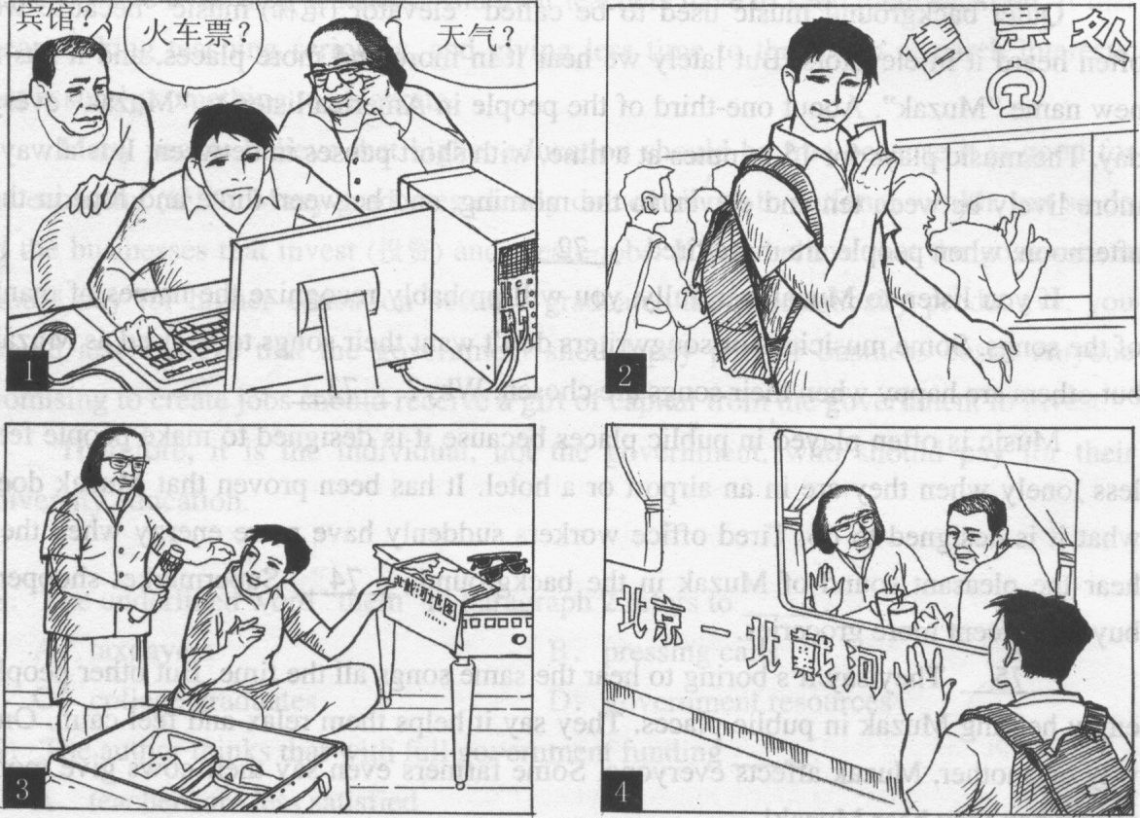
Last weekend, I helped my grandparents prepare their trip to Beidaihe.
___________________________________________________________________
___________________________________________________________________

